1. Open putty with configuration details as attached screenshot:

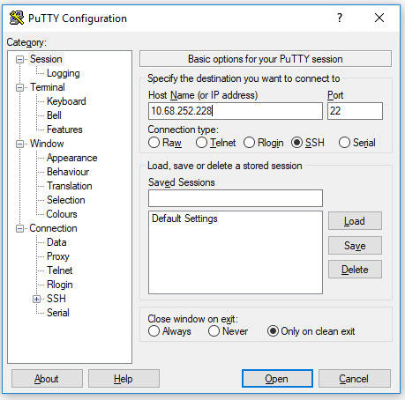

Other nodes are 225, 226, and 227 .

1. Login using username (root) and password.
2. First we need to stop all the chains

**multichain-cli chain_name stop**

1. First we check the space using command:

**df -kh**

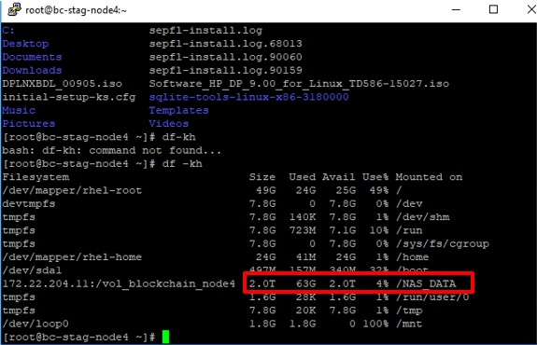

1. Above screenshot shows /NAS_DATA has 2T space. Hence we first copy and then move

**multichain data from current directory (/root/.multichain) to /NAS_DATA .**

1. We create a directory inside /NAS_DATA using

**mkdir multichain_data**

1. To access that chain we need to give the command

**chmod 777 -R multichain_data**

1. Copying from source to destination using command

**cp -r /root/.multichain/ /NAS_DATA/multichain_data/**

1. List hidden files

**ls -a**

o/p : .multichain

1. List of created chains can be viewed

**ls**

1. Running node:

**multichaind -datadir= /NAS_DATA/multichain_data/.multichain citizen_profile -daemon**

1. Node will be ready.
2. On second terminal we will run following command:

**Pwd**

o/p; /NAS_DATA

1. Make new directory inside current directory

**mkdir multichain_data_backup**

1. Accessing the chain

**chmod 777 -R multichain_data_backup**

**ls**

1. Moving the file from source to destination

**mv /root/.multichain/ /NAS_DATA/multichain_data_backup/**

---------------------------------------------------------------------------------------------------------